Home Security and Automation with IoT

“Project Titan”

BY

Mr. Vishal Thakur

Mr. Raghvendra Damle

Mr. Mohit

Mr. Anup Kumar Singh

|  |  |  |
| --- | --- | --- |
|  | **INDEX** |  |
| Sr.No. | Content | Page |
| 1 | Introduction | 6 |
| 2 | Product Description | 7 |
| 3 | Internet of Things | 8 |
| 4 | Cloud | 10 |
| 5 | MySQL | 11 |
| 6 | Raspberry Pi | 12 |
| 7 | Actuators | 15 |
| 8 | Sensors | 19 |
| 9 | Other electrical components | 23 |
| 10 | Cayenne | 26 |
| 11 | Use Case Diagrams | 27 |
| 12 | Circuit Diagrams | 30 |
| 13 | Limitations and Future Work | 32 |
| 14 | Conclusion | 33 |
| 15 | Modules for Future Work | 34 |
| 16 | Bibliography | 36 |

# Introduction

In recent years with all members of a household having to leave their home for jobs, schooling ;their homes are at the risk of burglars, intruders. Home security is a major concern, it is almost an essential requirement of most households. Major IT giants like Amazon, Google, Microsoft, CISCO, Oracle have invested in home security research, they are also funding University research in this area. Today there is technology which can make our homes intelligent and safe, house owners can monitor and control their home appliances from anywhere. Wireless technology is extensively used to control home appliances instead of wired connection.

We chose to do this Home security project so that we can control and secure our home appliances via the internet and further it is expensive to purchase an automation and security system, so we decided of making our own system which can be used in our homes and can also be further extended and modified.

A major objective of home automation and security is to help handicapped citizens and senior citizens to control home appliances remotely and alert them in critical situations.

Product Description

The Smart Home Security and Automation System is a product to fight against intruders and help to do tasks automatically in a home. It can detect any theft attack and send alarm email to owner’s phone with the picture of intruder.

The product uses devices such as Raspberry Pi,arduino, motors, various modules like RFID,keypad, fingerprint reader and software’s to communicate with these devices.

A brief description of the Smart Home System product is,

* A fingerprint reader is placed at the main gate to allow entry to authorised household people.
* The Smart Home System has smart door locking, where the user has an authenticated RFID card to unlock the door.
* The Smart Home System has a automated entrance gate which runs on controlled motors.
* Cayenne software is used to give commands remotely to the home.
* Alerting email is sent to registered account of household admin in case a person/intruder tries to enter the house forcefully without having valid RFID tag or an unregistered fingerprint.

Internet of Things (IoT)

[](https://www.google.com/url?sa=i&rct=j&q=&esrc=s&source=images&cd=&cad=rja&uact=8&ved=2ahUKEwjx0rKD4sfgAhVKOisKHY_ACTgQjRx6BAgBEAU&url=https://www.kisspng.com/png-logo-internet-of-things-narrowband-iot-universal-w-5685226/&psig=AOvVaw3I5D24ZiKjKIbmHQqWTVoZ&ust=1550664605992398)

Internet of Things (IoT) is a system of connected objects that are accessible through the internet. It is the network of devices and appliances that contain electronics, software, sensors, actuators and connectivity which allows these things to connect, interact and exchange data.

Increasingly, organizations in a variety of industries are using IoT to operate more efficiently, better understand customers to deliver enhanced customer services, improve decision-making and increase the value of the business. IoT has evolved into machine-to-machine communication, i.e. machines connecting to each other via a network without human interaction. It involves connecting a device to the cloud managing it and collecting data.

An IoT system consists of web-enabled smart devices that use embedded processors, sensors and communication hardware to collect, send and act on data they acquire from their environments. IoT devices share the sensor data they collect by connecting to an IoT gateway or other edge device where data is either sent to the cloud to be analysed or analysed locally. Sometimes, these devices communicate with other related devices and act on the information they get from one another. The devices do most of the work without human intervention, although people can interact with the devices for instance, to set them up, give them instructions or access the data.

**Benefits of IoT:**

Internet of things offers a number of benefits to organizations, enabling them to:

Monitor overall business processes

Improve the customer experience

Save time and money

Enhance employee productivity

Integrate and adapt business models

Make better business decisions

Generate more revenue.

The Smart Home System product uses IoT to control its modules remotely via internet. Household users can send commands to turn lights, alarm and open/close doors remotely.

Cloud



Cloud is a network of remote servers hosted on the internet and used to store, manage and process data in place of local servers or personal computers.

Cloud Computing is the use of hardware and software to deliver a service over a network. With cloud computing, users can access files and use applications from any device that can access the Internet. The Cloud Computing market has been growning year after year because companies are becoming more aware of the cost saving benefits of adopting the cloud.

An example of a Cloud Computing provider is Google's Gmail. Gmail users can access files and applications hosted by Google via the internet from any device.

**Cloud storage** provides a safer and more accessible place to store data than traditional computing methods. Keeping essential documents in a central online storage location makes it easier for everyone to access them. Cloud storage is vital for businesses with employees whom all need to obtain the same information to do their work. It increases collaboration and efficiency among organizations.

An example of this is Google Drive, where we can store all our files.

Backing up files in the cloud is by far the most efficient way to ensure their availability. Cloud backup solutions create multiple copies of files and store data in different locations. This way, you do not have to worry that your files will be lost in case one of your or your provider’s cloud server goes down.

There are public, private and hybrid clouds. Also various offerings of cloud are SaaS(Software as a service),PaaS(Platform as a service) and IaaS(Infrastructure as a service).

The Smart Home System product uses the cloud to send e-mails to the household admin, alerting him about any attempts of intrusion.

[](https://www.google.com/url?sa=i&rct=j&q=&esrc=s&source=images&cd=&cad=rja&uact=8&ved=2ahUKEwj6qvz14MfgAhVUfn0KHdyPAXcQjRx6BAgBEAU&url=https://en.wikipedia.org/wiki/MySQL&psig=AOvVaw096YtHt7YGaQKM-sFeC6AU&ust=1550664315466981)MySQL

MySQL is a fast, easy-to-use RDBMS being used for many small and big businesses.

MySQL is famous for following good reasons :

* MySQL is released under an open-source license. So you have nothing to pay to use it.
* MySQL is a very powerful program in its own right.
* MySQL works on many operating systems and with many languages including PHP, PERL, C, C++, JAVA, etc.
* MySQL works very quickly and works well even with large data sets.
* MySQL is very friendly to PHP, the most appreciated language for web development.
* MySQL supports large databases, up to 50 million rows or more in a table.
* MySQL is customizable. The open-source GPL license allows programmers to modify the MySQL software to fit their own specific environments.

The Smart Home System product uses MySql to manage and store the database locally on the Raspberry Pi. The database stores details of the date-time of any person trying to enter.

There are two tables named Intruder and DataLog. DataLog table stores the date, time and image of the person who uses fingerprint scanner. Intruder table makes the entry for every wrong input and is sent to the admin via e-mail.

**Database name: data log**

**Tables:**

1. **Intruder log:** Makes entry for incorrect authentication

|  |  |  |
| --- | --- | --- |
| **Column Name** | **Data Type** | **Description** |
| Date Time | Date time | Stores date and time of intrusion |
| Image | Blob | Stores the image of intruder |

|  |  |  |
| --- | --- | --- |
| **Column Name** | **Data Type** | **Description** |
| Date Time | Date time | Stores date and time of intrusion |

1. **General log:** Makes entry for each successful authentication

Raspberry Pi

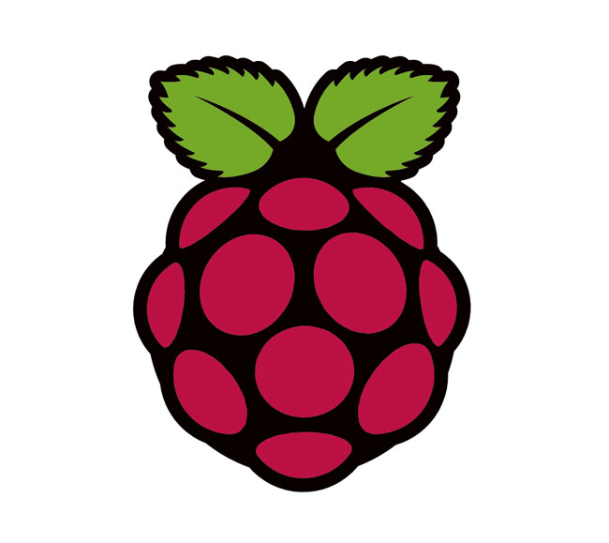

Raspberry Pi is a low cost, credit-card sized computer that plugs into a computer monitor or TV, and uses a standard keyboard and mouse. It is a capable little device that enables people of all ages to explore computing, and to learn how to program in languages like Scratch and Python. It’s capable of doing everything you’d expect a desktop computer to do, from browsing the internet and playing high-definition video, to making spreadsheets, word-processing, and playing games.

What’s more, the Raspberry Pi has the ability to interact with the outside world, and has been used in a wide array of digital maker projects, from music machines and parent detectors to weather stations and tweeting birdhouses with infra-red cameras. Raspberry Pi is being used by kids all over the world to learn to program and understand how computers work.

**What are the differences in Raspberry Pi models?**

There are two Raspberry Pi models, the A and the B. A is cheaper and uses less power than the B.

The Raspberry Pi A and B boards been upgraded to the A+ and B+ respectively. These upgrades make minor improvements, such as an increased number of USB ports and improved power consumption, particularly in the B+.

**Raspberry Pi 3 B**

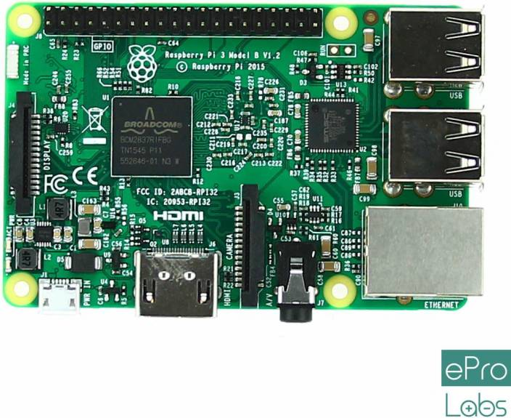

• Quad Core 1.2GHz Broadcom BCM2837 64bit CPU

• 1GB RAM

• wireless LAN and Bluetooth Low Energy (BLE) on board

• 100 Base Ethernet

• 40-pin extended GPIO

• 4 USB 2 ports

• 4 Pole stereo output and composite video port

• Full size HDMI

• CSI camera port for connecting a Raspberry Pi camera

• DSI display port for connecting a Raspberry Pi touchscreen display

• Micro SD port for loading your operating system and storing data

• Upgraded switched Micro USB power source up to 2.5A

**Raspberry Pi 3 B+**

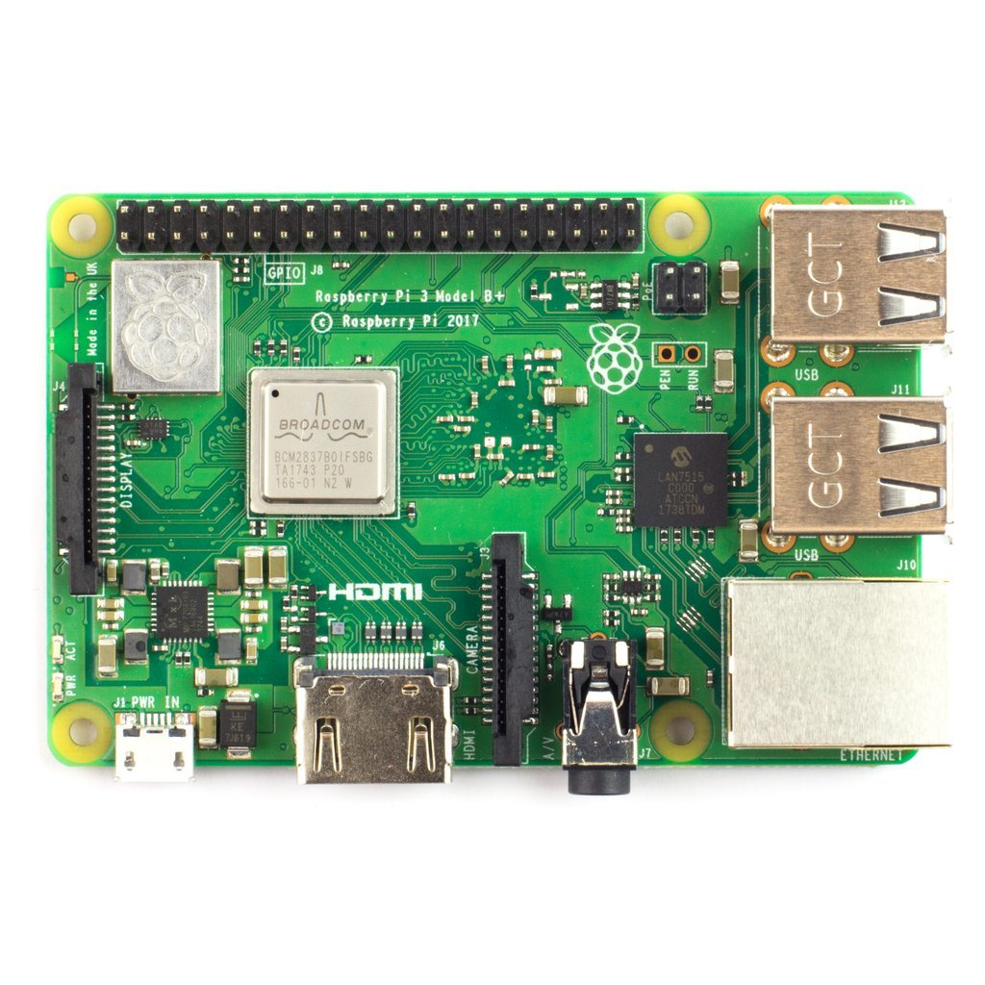

The Raspberry Pi 3 Model B+ is the latest product in the Raspberry Pi 3 range.

• Broadcom BCM2837B0, Cortex-A53 (ARMv8) 64-bit SoC @ 1.4GHz

• 1GB LPDDR2 SDRAM

• 2.4GHz and 5GHz IEEE 802.11.b/g/n/ac wireless LAN, Bluetooth 4.2, BLE

• Gigabit Ethernet over USB 2.0 (maximum throughput 300 Mbps)

• Extended 40-pin GPIO header

• Full-size HDMI

• 4 USB 2.0 ports

• CSI camera port for connecting a Raspberry Pi camera

• DSI display port for connecting a Raspberry Pi touchscreen display

• 4-pole stereo output and composite video port

• Micro SD port for loading your operating system and storing data

• 5V/2.5A DC power input

• Power-over-Ethernet (PoE) support

Actuators

An **actuator** is something that converts energy into motion, so basically it’s an output device. It also can be used to apply a force. An actuator typically is a mechanical device that takes energy and converts it into some kind of motion. That motion can be in virtually any form, such as blocking, clamping or ejecting. Actuators typically are used in manufacturing or industrial applications and might be used in devices such as motors, pumps, switches and valves.

**1. Motors**

An electric motor is a rotating electrical machine that converts electric energy into mechanical energy. Most electric motors

A: Stepper Motor

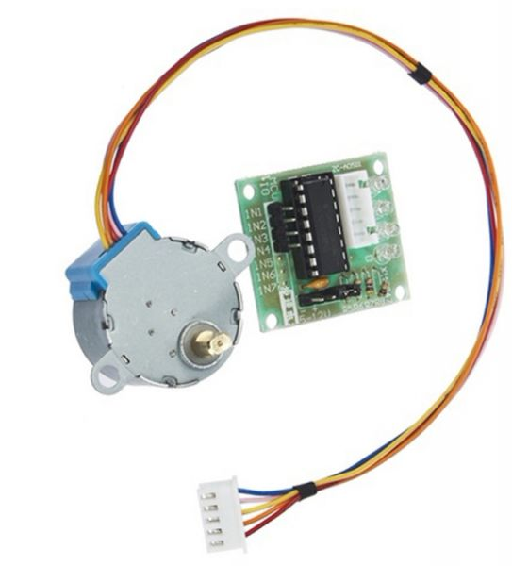

Stepper motors fall somewhere in between a regular DC motor and a servo motor. They have the advantage that they can be positioned accurately, moved forward or backwards one 'step' at a time, but they can also rotate continuously.

Stepper motors are brushless DC motors whose rotation is divided into a distinct number of steps which provides very accurate positional control and repeatability.

With a computer controlled stepping you can achieve very precise positioning and/or speed control. For this reason, stepper motors are the motor of choice for many precision motion control application.

They are very popular for 3D printers and robotics.

B: Servo Motor

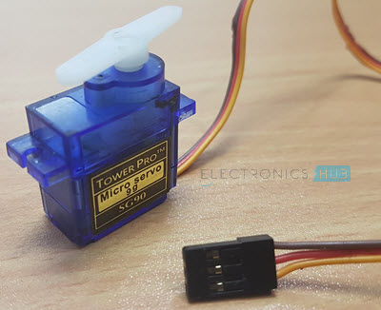

Servo motors are controlled by pulses of varying lengths. This requires fairly accurate timing. The Raspberry Pi has one pin that generates pulses in hardware, without having to rely on the operating system.

Servo motors are popular in radio-controlled devices such as model aircraft and toy cars. Sophisticated servo motors for industrial use have both position and speed sensing, allowing the motor to be brought to its position quickly and precisely without overshooting, as the speed of the shaft can also be controlled.

**2: Piezo buzzer**

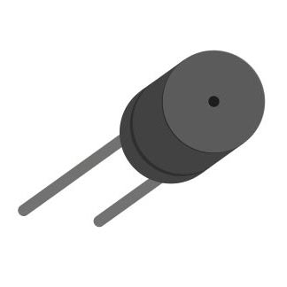

A Piezo buzzer is a device that is used to generate beep sound (generally a warning or alert in embedded system). It is a two leg device the longer leg is positive. If voltage is supplied it generates beep sound. Through analog write volume of beep can be controlled.

If a buzzer is switched with different time intervals it generates a melody.

**3: LED**

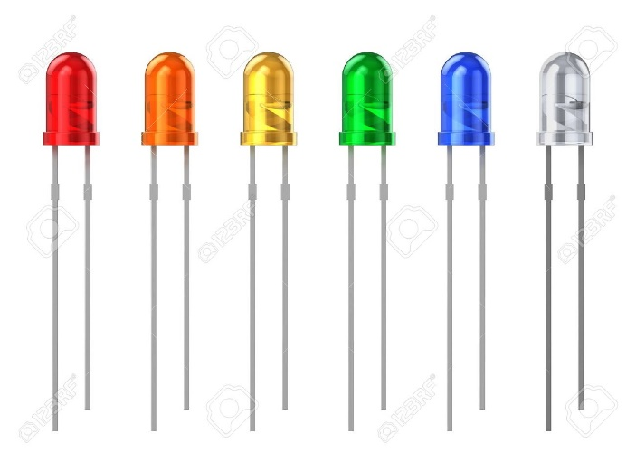

A light-emitting diode (LED) is a semiconductor device that emits visible light when an electric current passes through it. The light is not particularly bright, but in most LEDs it is monochromatic, occurring at a single wavelength.

An LED consists of two elements of processed material called P-type semiconductors and N-type semiconductors. These two elements are placed in direct contact, forming a region called the P-N junction, hence resembles most other diode types.

Sensors

A sensor is a device that detects and responds to some type of input from the physical environment. The specific input could be light, heat, motion, moisture, pressure, or any one of a great number of other environmental phenomena. The output is generally a signal that is converted to human-readable display at the sensor location or transmitted electronically over a network for reading or further processing.

**1: Ultrasonic Sensor**

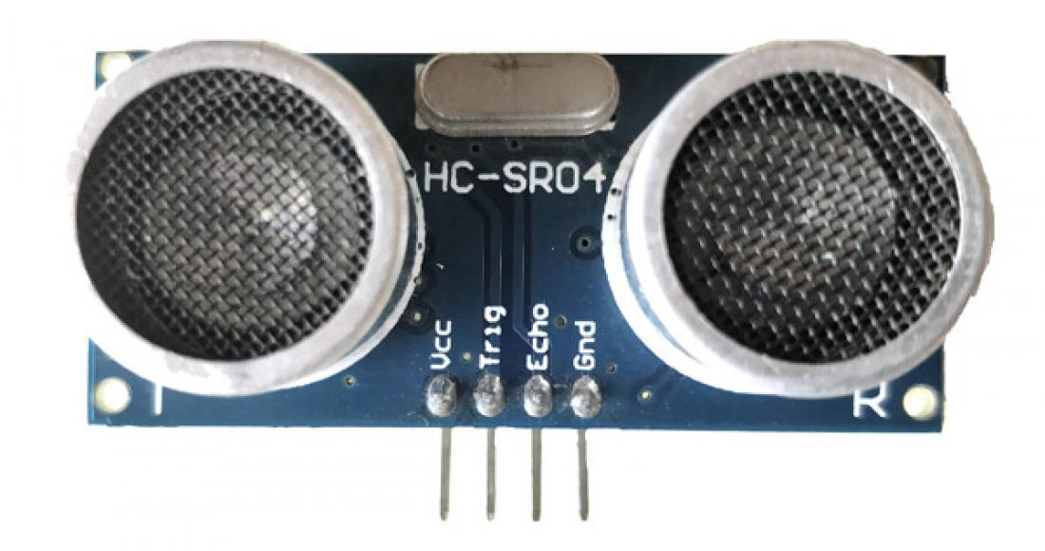

As the name indicates, ultrasonic sensors measure distance by using ultrasonic waves.

The sensor head emits an ultrasonic wave and receives the wave reflected back from the target. Ultrasonic Sensors measure the distance to the target by measuring the time between the emission and reception.

**2: Fingerprint Scanner**

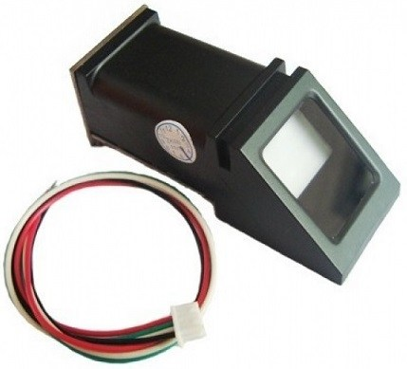

A fingerprint scanner typically works by first recording fingerprint scans of all authorized individuals for a particular system or facility. These scans are saved within a database. The user requiring access puts their finger on a hardware scanner, which scans and copies the input from the individual and looks for any similarity within the already-stored scans. If there is a positive match, the individual is granted access.

These modules come with FLASH memory to store the fingerprints and work with any microcontroller or system with TTL serial. These modules can be added to security systems, door locks, time attendance systems, and much more.

3: RFID

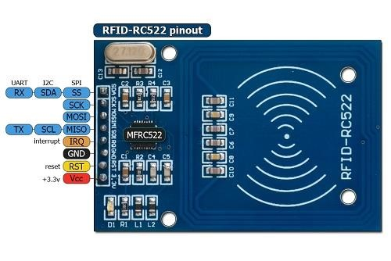

A contact-less transfers of data between the data-carrying device and its reader is far more flexible, the power required to operate the electronic data-carrying device would also be transferred from the reader using contact-less technology, because of the procedures used for the transfer of power and data. Contact-less ID System is called RFID system. The MF RC522 use of advanced modulation and demodulation concept completely integrated in all types of 13.56MHz passive contactless communication methods and protocols.

**4: Camera Module**

[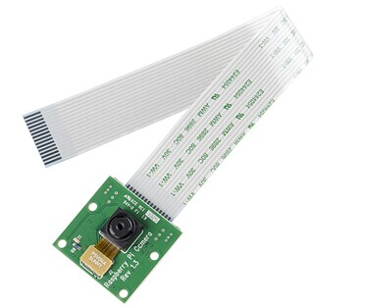](http://www.geeetech.com/wiki/index.php/File:Raspberry_Pi_Camera_Module.jpg)

The Raspberry Pi camera module is capable of taking full HD 1080p photo and video and can be controlled via programme.

The Raspberry Pi camera board v.1 has a 5 MP sensor, and connects via a ribbon cable to the CSI connector on the Raspberry Pi.

The "Pi Camera v2.1, in both normal and NoIR versions. It uses the Sony IMX219 8-megapixel sensor with a slightly wider (62 degrees H) and faster (f/2.0) lens. The board is the same 25 x 24 mm size, and is intended as a drop-in replacement for the previous camera.

Other Electrical COMPONENTS

**1: Resistor**

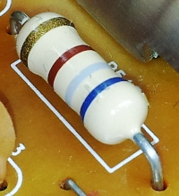

The resistor is a passive electrical component used to create resistance in the flow of electric current. In almost all electrical networks and electronic circuits they can be found. The resistance is measured in ohms.

The current is proportional to the voltage across the terminal ends. This ratio is represented by Ohm’s Law-

V=I*R

**Symbols:**

[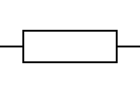](http://www.resistorguide.com/standards-and-codes/resistor-symbols/resistor-symbol/)[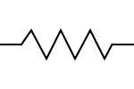](http://www.resistorguide.com/standards-and-codes/resistor-symbols/resistor-symbol-american/)

Fixed resistor symbol Fixed resistor symbol

**2: Jumper wires**

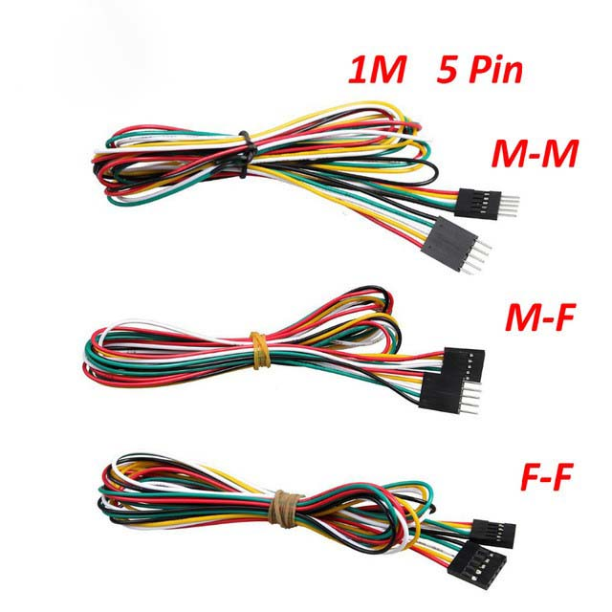

Jumper wires are simply wires that have connector pins at each end, allowing them to be used to connect two points to each other without soldering. Jumper wires are typically used with breadboard and other prototyping tools in order to make it easy to change a circuit as needed. Fairly simple. In fact, it doesn’t get much more basic than jumper wires.

Type of Jumper Wires

Jumper wires typically come in three versions: male-to-male, male-to-female and female-to-female. The difference between each is in the end point of the wire.

**3: Breadboard**

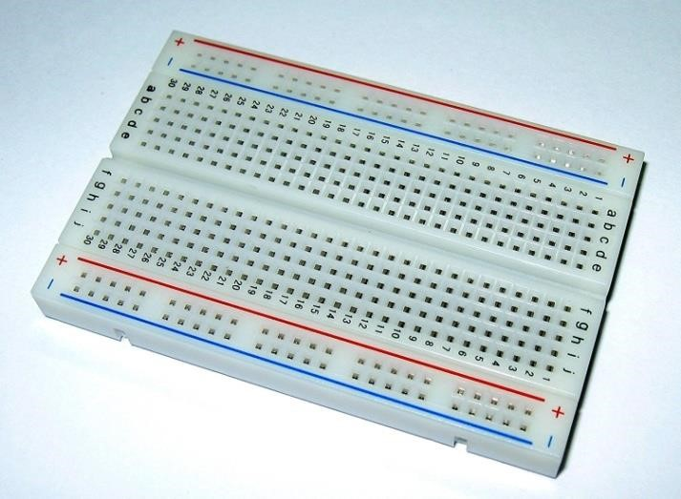

A breadboard is a solder less device for temporary prototype with electronics and test circuit designs. Most electronic components in electronic circuits can be interconnected by inserting their leads or terminals into the holes and then making connections through wires where appropriate. The breadboards have strips of metal underneath the board and connect the holes on the top of the board. Because the solder less breadboard does not require [soldering,](https://en.wikipedia.org/wiki/Soldering) it is reusable.

Cayenne

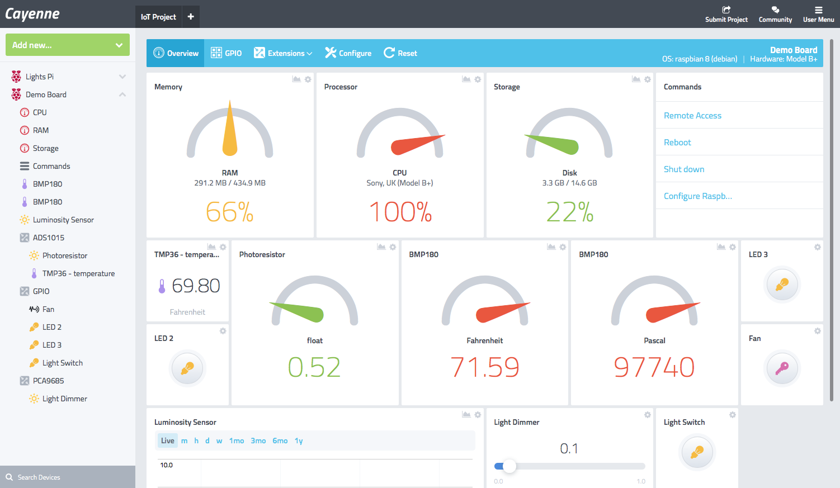

Cayenne is an online IoT dashboard that takes most of the complication out of creating hardware-oriented programing and supports Raspberry Pi.

Cayenne is a user friendly drag-and-drop programming system for the IoT. It not only makes it possible to build programs using drag-and-drop, it standardizes the connection of devices such as sensors and motors and makes sure that drivers are in place.

All you have to do is install the Cayenne agent using the web site. Once the Cayenne agent is installed you can interact with it via the mobile app or the website. Using the dashboard, you can monitor and configure the device, but more importantly you can install sensors.

With a sensor installed the dashboard will show you the current reading - temperature if it's a temperature sensor. In Cayenne you can add any of a range of actuators as output devices. These include relays, motors, ADCs and so on.

Cayenne has all of the standard sensors and actuators that turn up in projects and you can get them going in no time at all, mostly by just dragging-and-dropping.

Use Case Diagrams

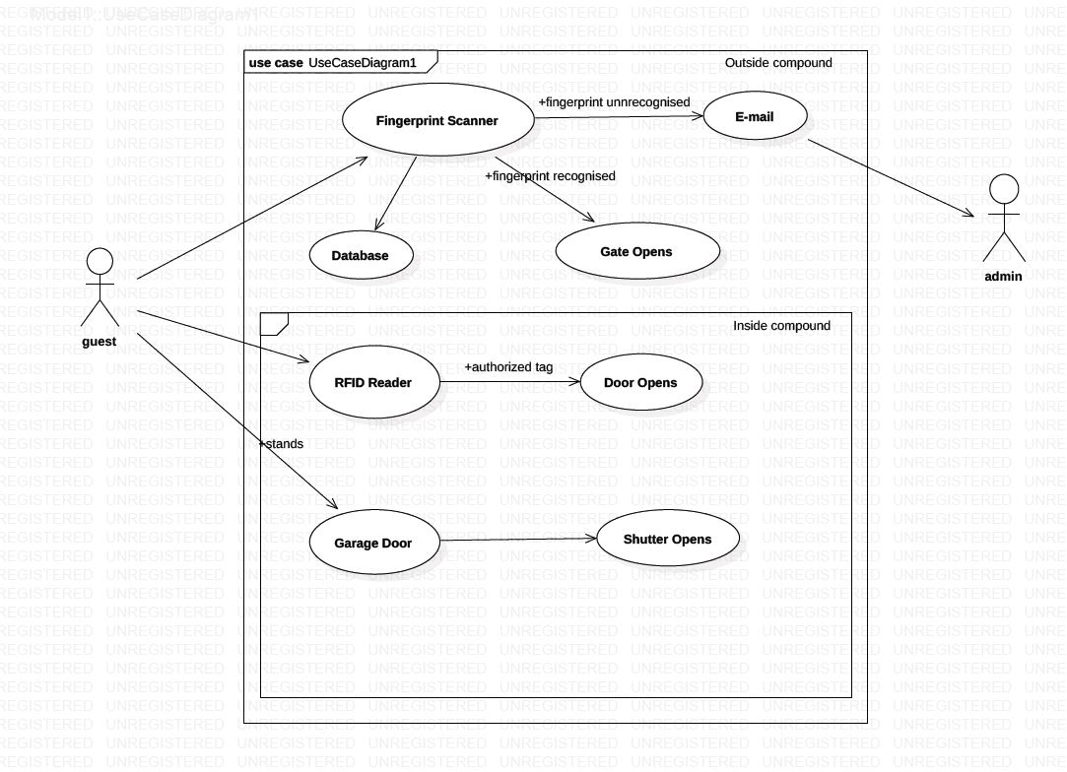**A: House**

**B: Cloud**

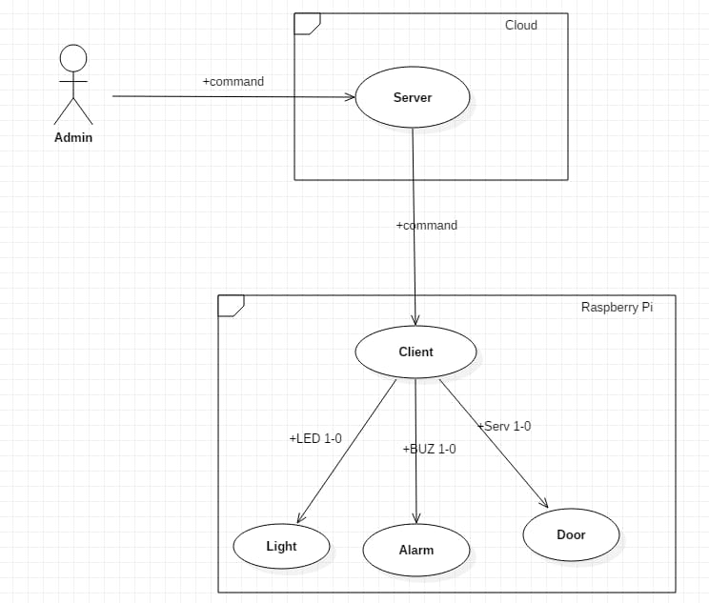

**C: GSM (Future work)**

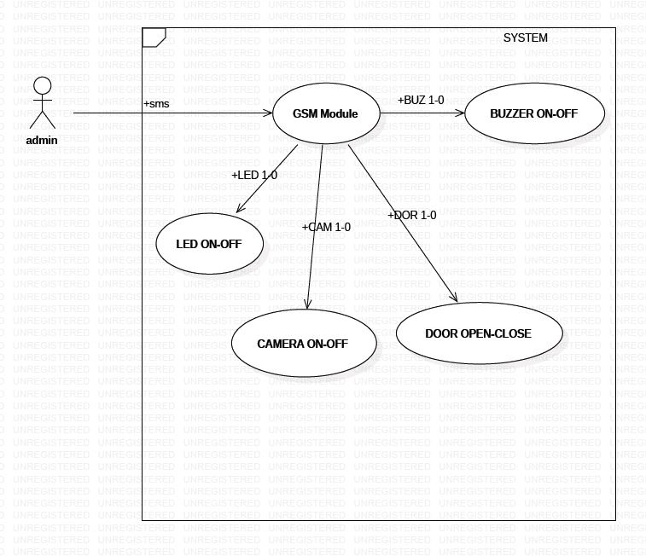

Circuit Diagrams

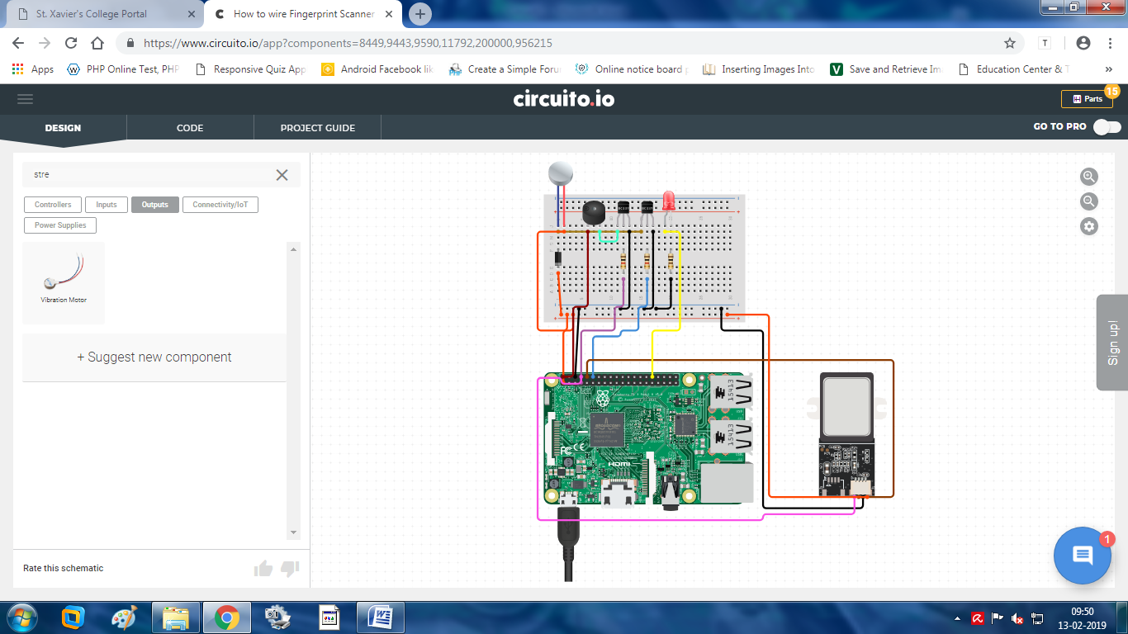**Gate:**

**Hall Entry:**

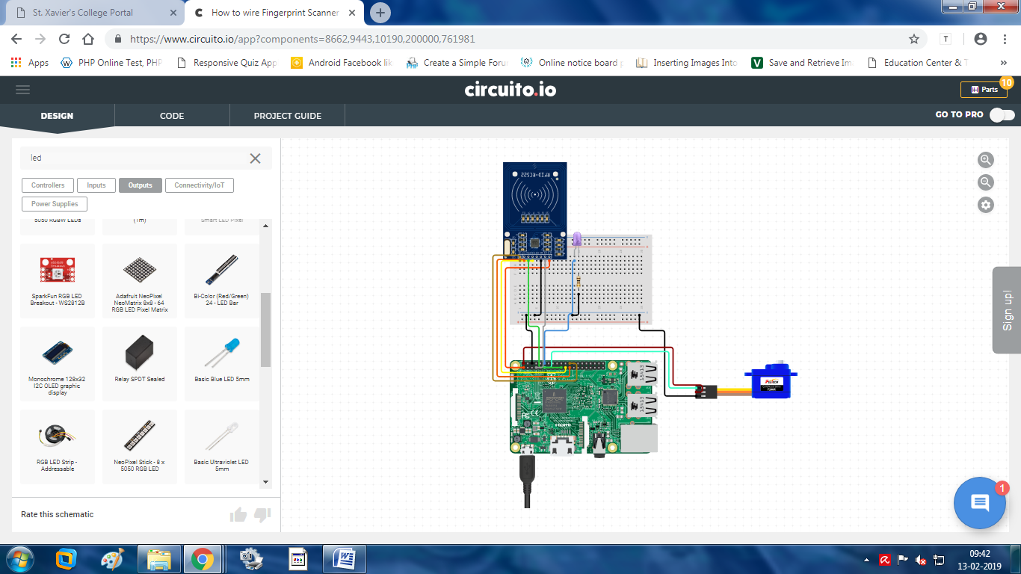

**Shutter:**

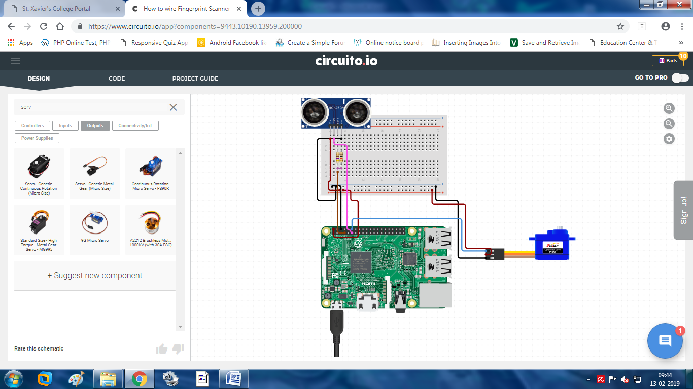

## Limitations and Future Work

## **Limitations:**

Though we tried our best ,the product has some limitations. Some of the limitations are

* The product just works with LAN and modules. No web server is made.
* User cannot view the live stream of current status of home.
* If sensors are damaged or don’t work properly then that sector of product will fail.

## **Future Work:**

The product has lot of scope for improvements, some tasks which can be added in near future are

* Using camera and image processing to detect known and unknown faces.
* NodeRed can be used to control the product remotely.
* We can implement web application with user friendly UI, can also add voice commands technology
* Safety measures when gas leakage or smoke is found, the product can alert to reduce the losses.

Conclusion

This Home security and automation System is cheaply made from low-cost easily available components and can be used to control more than hundred home appliances. This system is easily adjustable at any home or office space. The designed home automation system was tested a number of times and successfully controlled different home appliances. Finally, this home security and automation system can be also implemented over Ethernet, GSM and WIFI connectivity without much change to the design and yet still be able to control a variety of home appliances. Hence, this system is scalable and flexible.

Modules for Future work

**1: GSM Module**

[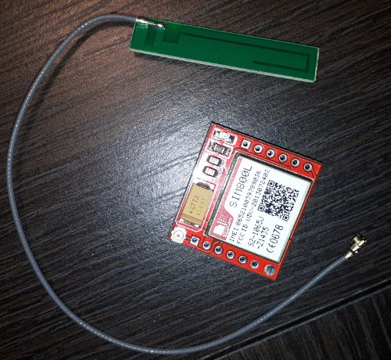](https://cdn.instructables.com/F32/A3LW/JEYIZJ9B/F32A3LWJEYIZJ9B.LARGE.jpg)

**GSM/GPRS module** is used to establish communication between a computer and a **GSM-GPRS system**. **GSM/GPRS module consists of a GSM/GPRS modem assembled together with power supply circuit and communication interfaces** for computer. GSM/GPRS MODEM is a class of wireless MODEM devices that are designed for communication of a computer with the GSM and GPRS network. It requires a **SIM (Subscriber Identity Module)** card just like mobile phones to operations:

1.      Receive, send or delete SMS messages in a SIM.

2.      Read, add, search phonebook entries of the SIM.

3.      Make, Receive, or reject a voice call.

# 2: Gas Sensor

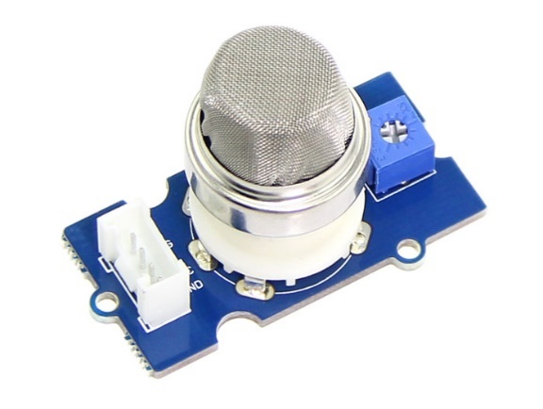

The Grove - Gas Sensor module is useful for gas leakage detecting. It can detect LPG, i-butane, methane, alcohol, Hydrogen, smoke and so on. Measurements can be taken as soon as possible based on its fast response time. Also the sensitivity can be adjusted by the potentiometer.

Bibliography

**Websites:**

1. https://www.researchgate.net/publication/311734099_Home_Automation_and_Security_System_smarthomes-technology.blogspot.com/
2. <https://www.slideshare.net/KapilGupta64/home-automation-and-security-system-66637866>
3. <https://www.engineersgarage.com/what-is-gsm-gprs-module>
4. <https://www.circuito.io/app?components=512,11021>
5. <https://mydevices.com/>
6. <https://howtoraspberrypi.com/>

**Books:**

1. Raspberry Pi 3 Projects for Java Programmers by Pradeeka Seneviratne and John Sirach
2. Raspberry PI: A Step By Step Guide for Beginners by Leonard Edison

**Videos:**

1. Udemy : Home Automation in 48 Hours by Venkatesh Varadchari, Satyajeet Sah
2. Udemy : Advanced Home Automation using Raspberry PI 3 by Venkatesh Varadchari, Satyajeet Sah, Venkatesh Gopalkrishnan
3. Raspberry PI projects : <https://www.youtube.com/watch?v=9YhTOUu06EY>
4. Introduction and Parts - Raspberry Pi and Python tutorials : <https://www.youtube.com/watch?v=RpseX2ylEuw>
5. Raspberry pi tutorial-part 7: Introduction to GSM SIM9000 Module

<https://www.youtube.com/watch?v=OSTKA2Q6Pos>